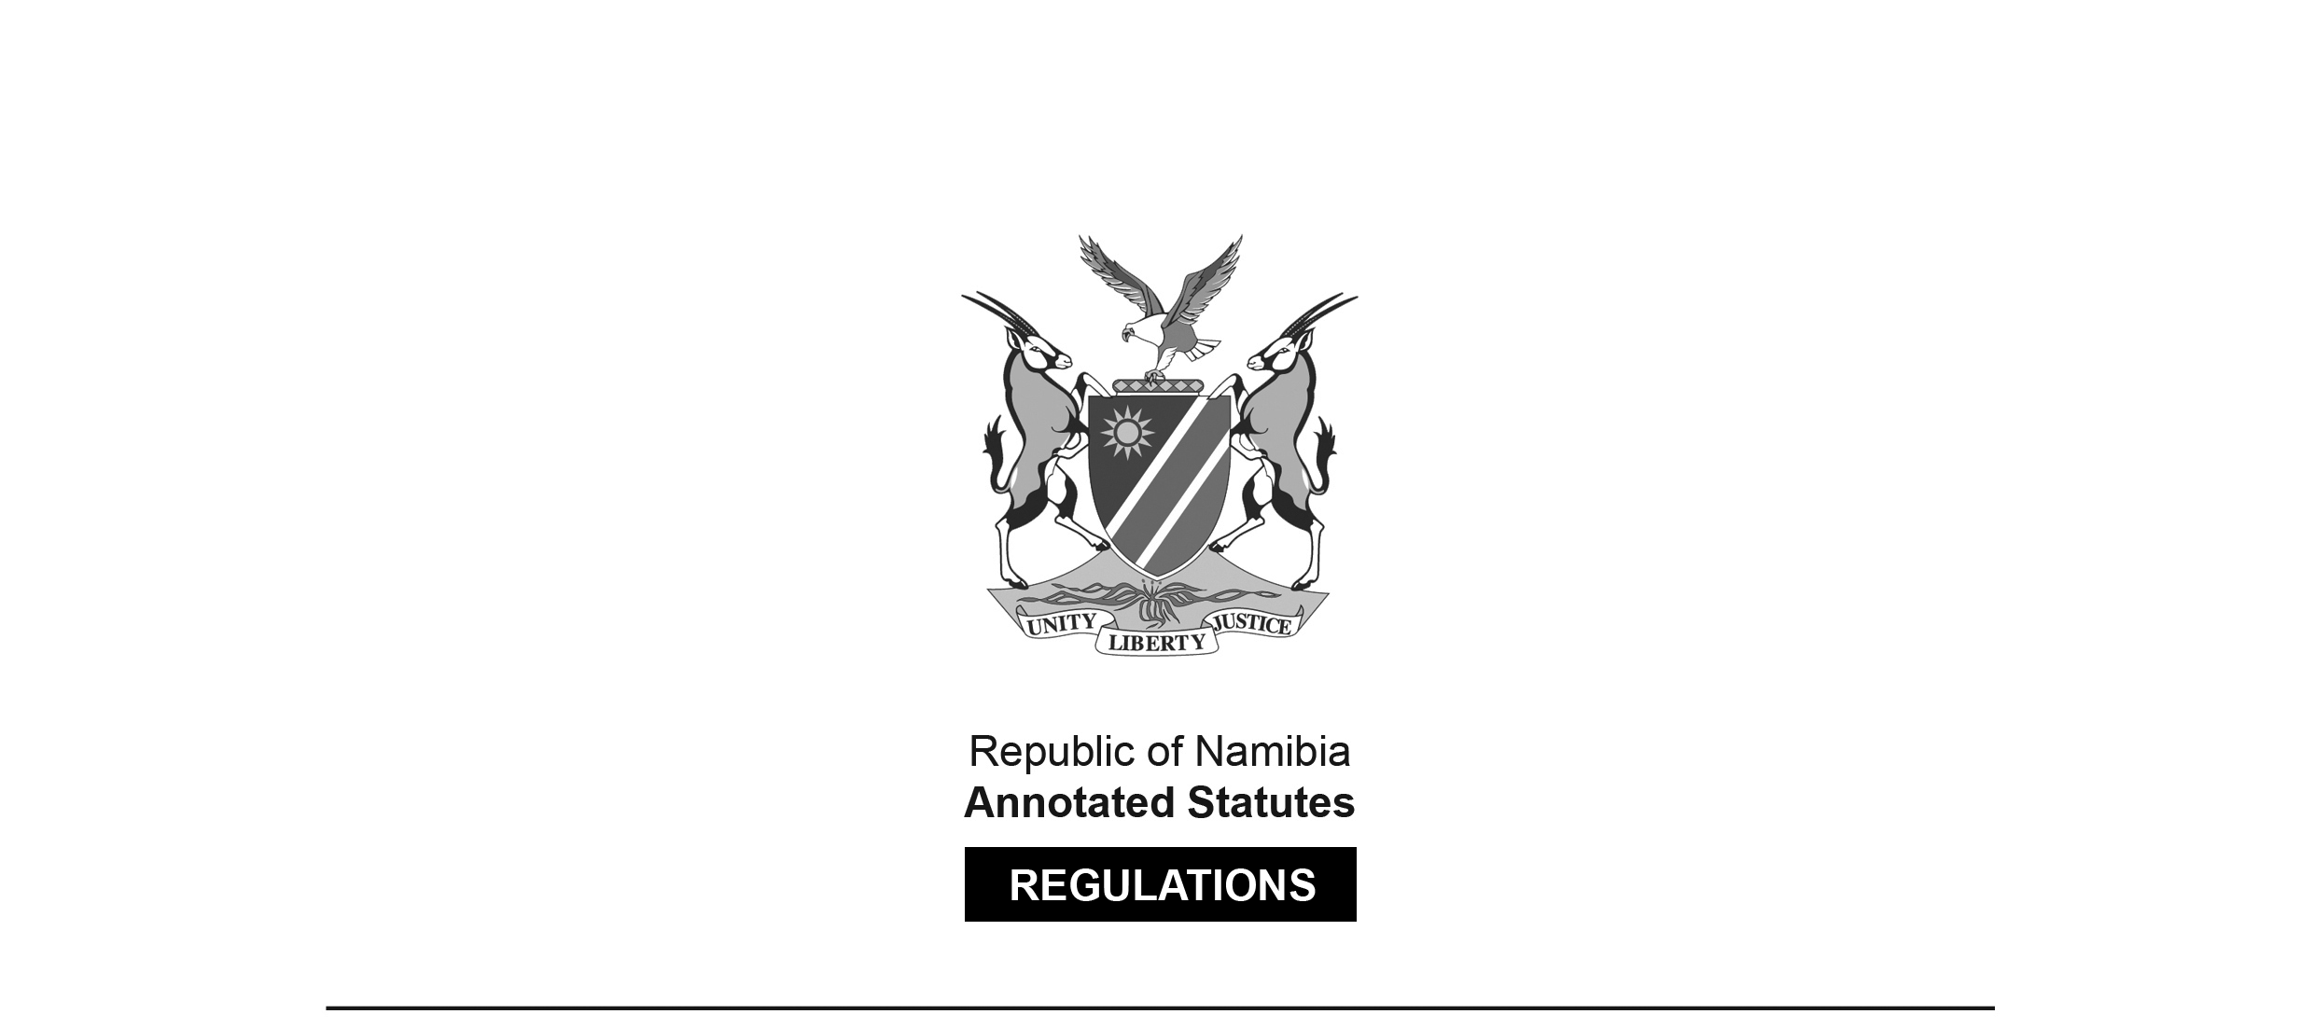

REGULATIONS MADE IN TERMS OF

Dairy Industry Act 30 of 1961

section 29

Regulations relating to the Taking of Samples of Dairy Produce for the purpose of Analysis or Examination   
under the Dairy Industry Act, 1961

RSA Government Notice R.2070 of 1964

(RSA GG 973)

came into force on date of publication: 11 December 1964

as amended by

RSA Government Notice R.176 of 1971 **(**[RSA GG 2991](http://www.lac.org.na/laws/GGsa/rsagg2991.pdf)**)**

came into force on date of publication: 12 February 1971

The *Dairy Industry Act 30 of 1961 (SA)* was applied to South West Africa only in so far as it relates to margarine, as a result of amendments made to the Act by the *Dairy Industry Amendment Act 7 of 1976* ([RSA GG 5015](http://www.lac.org.na/laws/GGsa/rsagg5015.pdf)), brought into force on 1 July 1976 by RSA Proc. R.103/1976 ([RSA GG 5161](http://www.lac.org.na/laws/GGsa/rsagg5161.pdf)). Section 1 as amended defines “Republic” as including the territory “in relation to margarine”, and the “territory” is defined as “the territory of South West Africa, including the Eastern Caprivi Zipfel”. Section 35A, inserted by *Act 7 of 1976*, states “This Act, and any amendment thereof which may be made from time to time, in so far as it relates to margarine or to a margarine factory,   
shall apply also in the territory.”

These regulations apply generally to samples of dairy produce   
and so would be relevant to margarine.

ARRANGEMENT OF REGULATIONS

[These regulations have no headings.]

**1.** An inspector taking a sample of dairy produce in terms of section *eleven* of the Dairy Industry Act, 1961, shall notify the person having apparent custody of such produce at the time of his intention to submit such sample for analysis or examination under the said Act.

**2.** (1) In the case of dairy produce contained in a package for the retail trade, an inspector shall, subject to the provisions of sub-regulations (2) and (3), divide the sample into three approximately equal parts of not less than 2 ounces each and place each part in a clean, dry container capable of air-tight closure. All three contains shall be securely closed, sealed and labelled, and the inspector shall tender to the person referred to in relation 1 any of the said containers. The remaining two containers shall be transmitted by the inspector to an analyst appointed in terms of section *ten* of the said Dairy Industry Act. Such analyst shall, after having removed from one such container as much of the sample as he may require for analysis or examination, seal up the remainder and retain it, together with the remaining third container, until any prosecution which may be instituted in connection with the sample has been concluded or an appeal, if any, in connection therewith has been heard.

(2) Where the contents of one package of such produce, or the contents of one package when divided as prescribed in sub-regulation (1), will provide a sample of less than 2 ounces, which is too small for purposes of analysis, the inspector shall take as a sample as many whole packages as he may deem necessary and place an equal number of such packaged into each of three clean, dry containers capable of air-tight closure. The said containers shall be further dealt with as prescribed in sub-regulation (1).

(3) Where dairy produce in semi-solid or fluid form is contained in a hermetically sealed package, an inspector shall take as a sample three such packages, all of which shall bear the same manufacturer’s identification markings. Such packages shall represent the three parts of the sample concerned and each shall be labelled and further dealt with as prescribe in sub-regulation (1).

**3.** In the case of butter packed in bulk, an inspector shall, by means of a butter trier of sufficient length to pass diagonally to the base of the carton or box concerned, take three cores of butter. Each core shall be obtained by inserting the trier from a top corner diagonally through the centre of the block of butter to the bottom. A plug of about one inch of such core shall be replaced in the hole from which the core was removed and the remainder of the core shall be transferred to a clean, dry sample container capable of air-tight closure. The trier shall be clean and dry before each drawing and while transferring the butter from trier to sample container, any moisture adhering to the outside of the trier shall not be included. The three sample containers concerned shall be further dealt with as prescribed in sub-regulation (1) of regulation 2.

**4.** In the case of a dairy product in powdered form packed in bulk, an inspector shall obtain a sample by means of a suitable clean, dry borer-tube. The tube shall be passed steadily through the powder at an even rate of penetration until it reaches the bottom of the package. It shall then be withdrawn and its contents discharged immediately into a clean, dry container capable of air-tight closure. The powder shall not be touched by hand. Three samples shall thus be taken and each discharged into a separate sample container. The three containers shall be further dealt with as prescribed in sub-regulation (1) of regulation 2.

**5.** (1) In the case of cheese not contained in packages for the retail trade, an inspector shall employ one of the following techniques, depending upon the shape, weight, type and maturity of the cheese: -

(a) Sampling by cutting a sector; or

(b) sampling by means of a trier.

[Although method (a) is preferable, method (b) is acceptable, especially where hard cheese of large size is concerned.]

[The information in square brackets appears in the *Government Gazette*.]

(2) (a) *Sampling by Cutting a Sector*.—Using a knife with a pointed blade, four cuts radiating from the centre of the cheese shall be made to give three sectors of approximately equal size. The size of each sector shall be such that, after removal of the inedible or horny surface layer, the remaining edible portion shall weight not less than two ounces.

[The word “weigh” is misspelt as “weight” in the *Government* *Gazette*, as reproduced above.]

(b) *Sampling by Means of a Trier*.—Depending on the shape, type and weight of the cheese, the trier shall be inserted either -

(i) into the top face obliquely towards the centre of the cheese from a point about one-third of its diameter from the edge, or

(ii) horizontally into the vertical face of the cheese, midway between the two place faces, towards the centre of the cheese.

As many cores shall be taken from a cheese as are required to make up three approximately equal samples each weighing not less than two ounces.

(3) Immediately after sampling, each sample obtained as prescribed in sub-regulation (2) shall be placed in a clean, dry container capable of air-tight closure. Such samples may be cut into pieces from insertion into containers but they shall not be compressed. They may also be wrapped in plastic film before being placed in the containers. The three containers shall be further dealt with as prescribed in sub-regulation (1) of regulation 2.

**6.** The label which in terms of these regulation sis required to be attached to each container, shall reflect the following information: -

(a) The nature of the dairy product sample;

(b) the name and address of the manufacturer thereof;

(c) any code markings that may appear thereon relating to the date of manufacture of such product;

(d) the name of the inspector taking the sample and such inspector’s signature; and

(e) the date of sampling.

**7.** Where a sample of milk or cream is obtained under these regulations, an inspector may add a preservative to each portion of such sample, in which case the kind of preservative used shall be stated on the label referred to in regulation 6.

**8.** The certificate of examination referred to in sub-section (1) of section twenty-seven of the Dairy Industry Act, 1961, shall be furnished in the form as set out in the Annexure to these regulations.

ANNEXURE

[Annexure amended by RSA GN R.176/1971]

__________

REPUBLIC OF SOUTH AFRICA

__________

DAIRY INDUSTRY ACT, 1961

__________

CERTIFICATE OF EXAMINATION

__________

To (1)

I, an analyst duly appointed under the Dairy Industry Act, 1961, hereby certify that on the

day of I received from

of an intact package sealed with an official seal No. (*)

which seal was intact. The package bore a label stating that the sample consisted of .

I have analysed the said sample and declare that the result of my examination is as follows

I am of the opinion that the sample

Signed

Analyst

Place

Date

(1) This certificate shall be furnished in duplicate and directed to the Chief, Division of Inspection Services, Private Bag 258, Pretoria.

(*) The seal used shall be described under “result of examination” if an official seal was not used.